
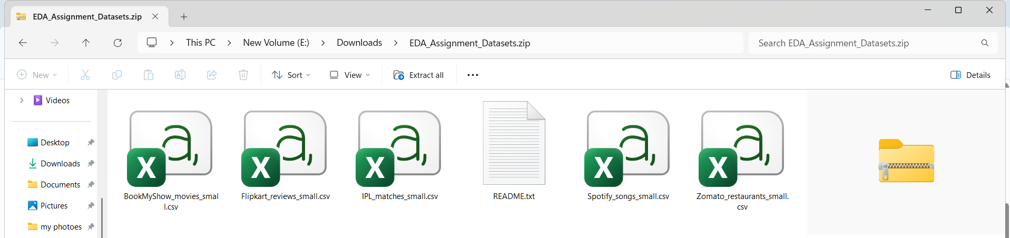
Question : 1
Download a small dataset of IPL cricket matches (CSV or Excel), load it into a pandas DataFrame, and perform univariate analysis by printing the summary statistics (mean, median, min, max, std) for the 'total_runs' column :

import pandas as pd
df = pd.read_csv("IPL_matches_small.csv")
print("First 5 rows:")
print(df.head())

print("\nSummary Statistics of total_runs:")
print("Mean:",df["total_runs"].mean())
print("Median:",df["total_runs"].median())
print("Minimum:",df["total_runs"].min())
print("Maximum:",df["total_runs"].max())
print("Standard Deviation:",df["total_runs"].std())
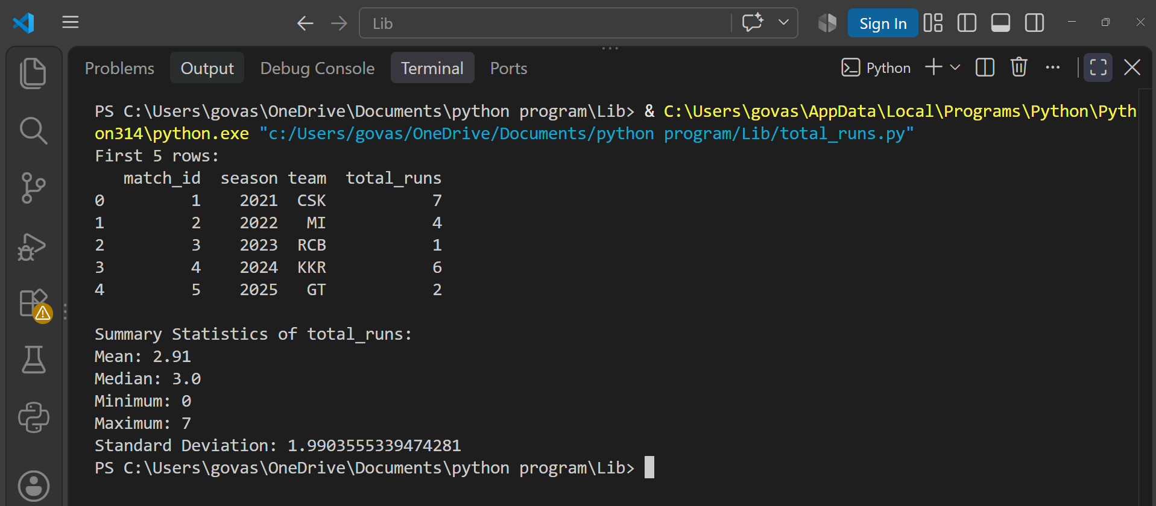

Question : 2
Using a dataset of Flipkart product reviews (at least columns: 'rating', 'category'), create a bar plot showing the count of reviews for each rating (1-5 stars) using matplotlib or seaborn :

import pandas as pd
import matplotlib.pyplot as plt
import seaborn as sns

df = pd.read_csv("Flipkart_reviews_small.csv")
print("First 5 rows:")
print(df.head())
rating_counts = df["rating"].value_counts().sort_index()
print("\nReview Count by Rating:")
print(rating_counts)

sns.barplot(x=rating_counts.index, y=rating_counts.values)
plt.xlabel("Rating (Stars)")
plt.ylabel("Number of Reviews")
plt.title("Count of Reviews for Each Rating")

plt.show()

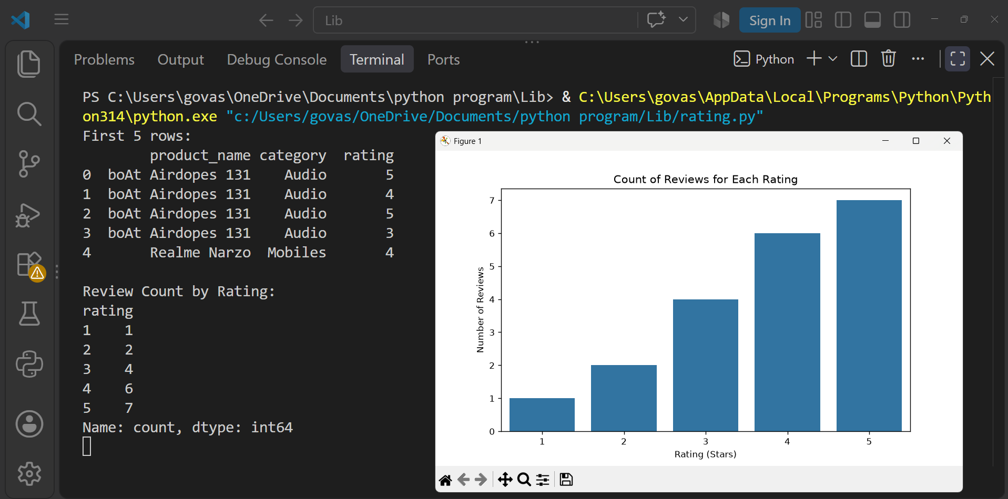
Question : 3
Take a dataset of Zomato restaurant listings (with 'average_cost_for_two' and 'user_rating' columns) and create a scatterplot to visualize the relationship between cost and user rating.<br><br><em><strong>Hint:</strong> Use seaborn's scatterplot() function and label the axes clearly : </em>

import pandas as pd
import seaborn as sns
import matplotlib.pyplot as plt

df = pd.read_csv("Zomato_restaurants_small.csv")
print("First 5 rows:")
print(df.head())

sns.scatterplot(x="average_cost_for_two",y="user_rating",data=df)
plt.xlabel("Average Cost for Two")
plt.ylabel("User Rating")
plt.title("Relationship Between Cost and User Rating")
plt.show()
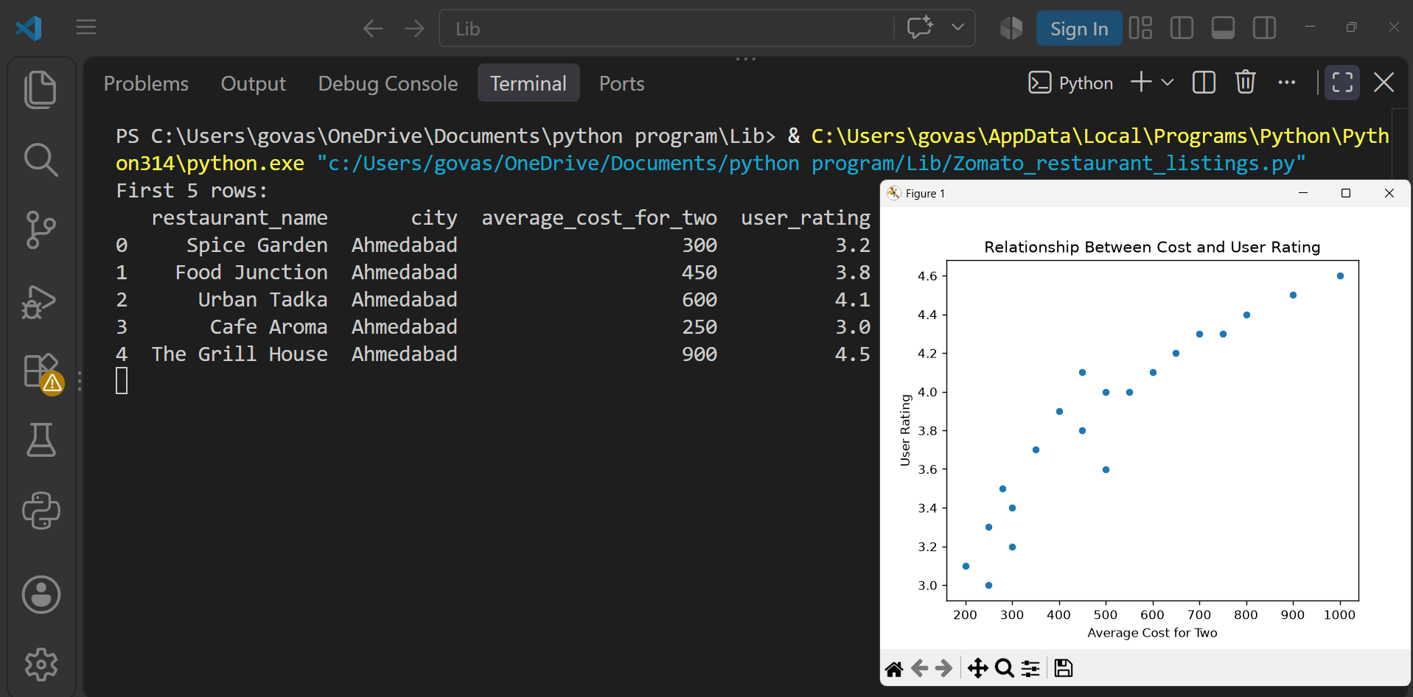

Question : 4
For a BookMyShow movie dataset (with 'genre' and 'box_office_collection' columns), use groupby analysis to find the average box office collection for each genre and display the results as a sorted table :

import pandas as pd
df = pd.read_csv("BookMyShow_movies_small.csv")
print("First 5 rows:")
print(df.head())
genre_average = df.groupby("genre")["box_office_collection"].mean()
genre_average = genre_average.sort_values(ascending=False)
print("\nAverage Box Office Collection by Genre:")
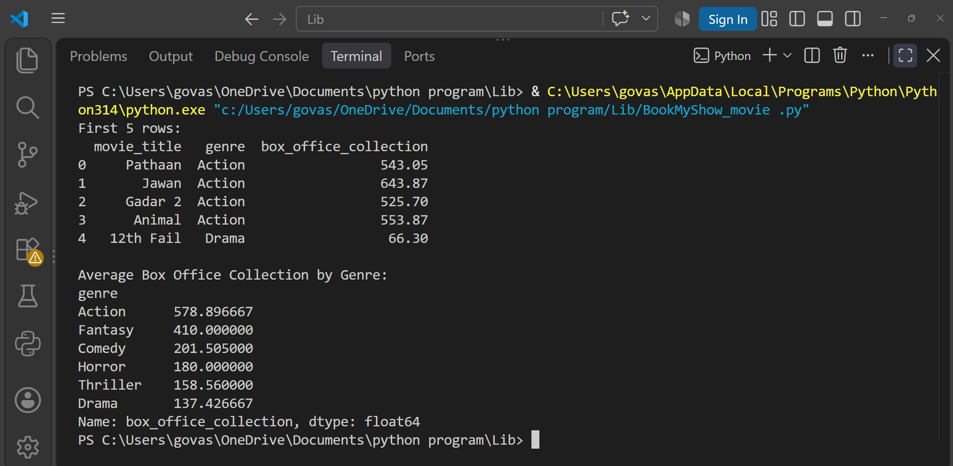
print(genre_average)
Question : 5
Use the seaborn 'pairplot' function on a Spotify songs dataset (with at least 'danceability', 'energy', 'valence', and 'popularity' columns) to visualize pairwise relationships between these features. Briefly describe one interesting pattern you observe :

import pandas as pd
import seaborn as sns
import matplotlib.pyplot as plt
df = pd.read_csv("Spotify_songs_small.csv")
print("First 5 rows:")
print(df.head())
features = ["danceability","energy","valence","popularity"]
sns.pairplot(df[features])
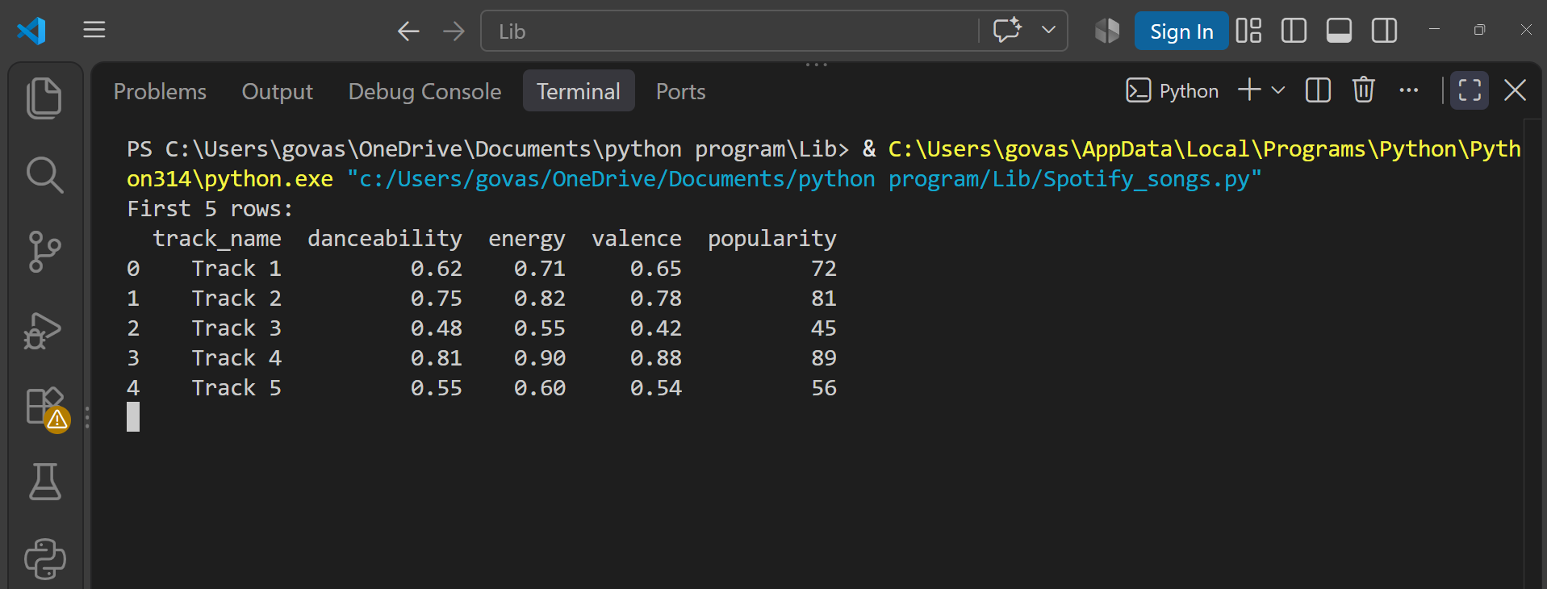
plt.show()
